Marmaris (East Side)
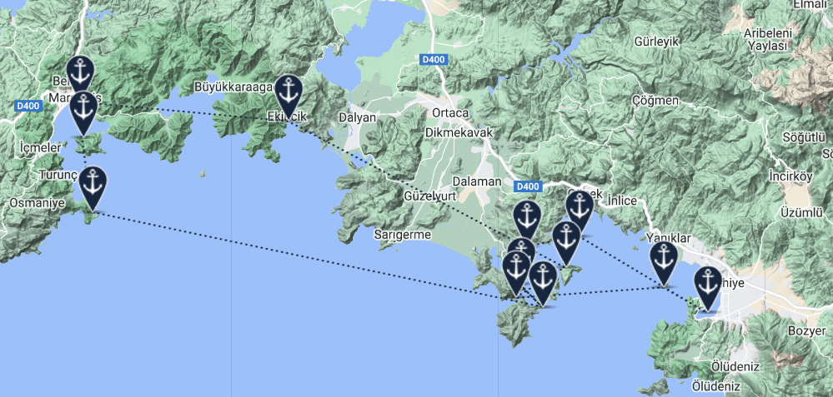

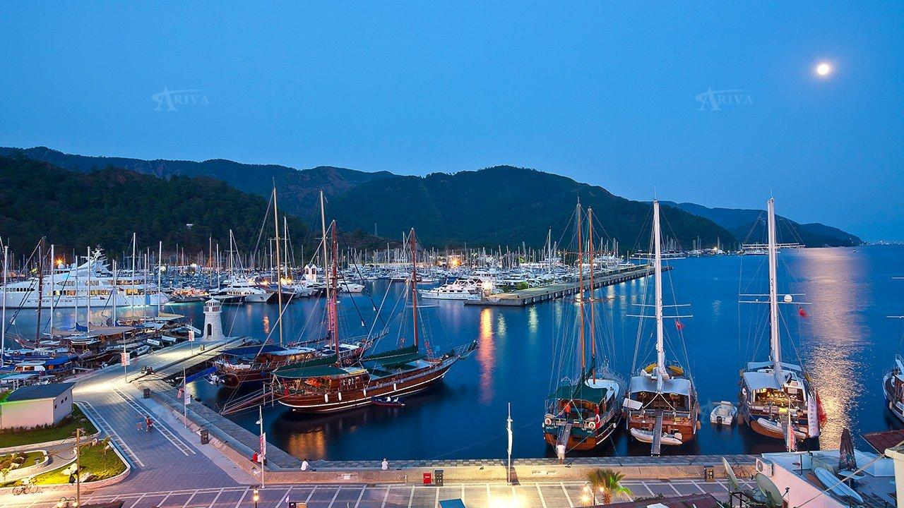
Marmaris
Marmaris is a port town and tourist resort on the Mediterranean coast, located in Mugla Province, southwest Turkey, along the shoreline of the Turkish Riviera.
Guests can board their yacht in mid-afternoon but there is still time to see what Marmaris has to offer before setting sail. With the days ahead likely to be quiet and relaxing on board your luxury charter, you may like to enjoy the busy streets and bars before returning to your yacht for a good night’s sleep.

33
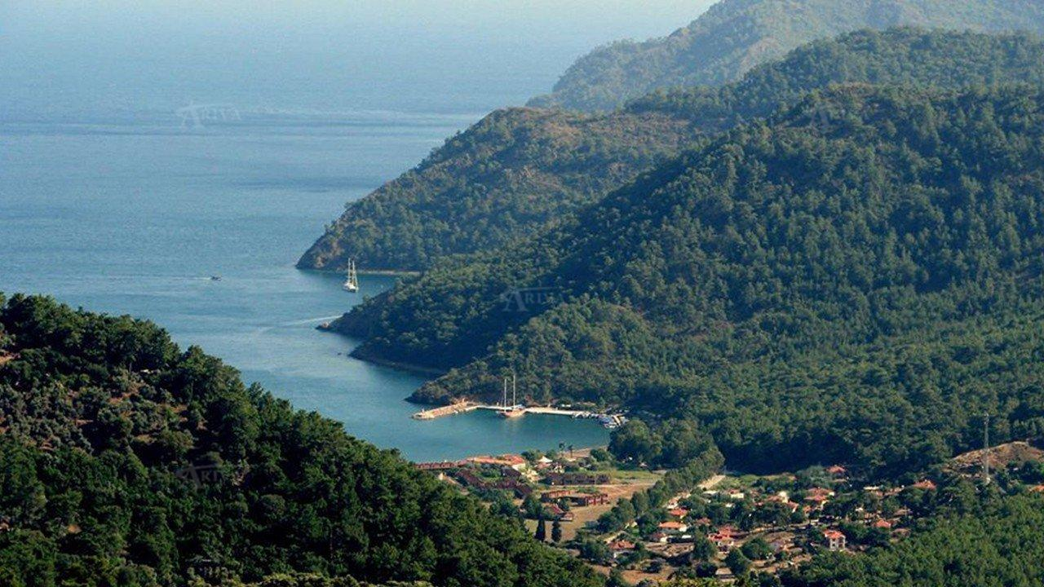
Ekincik (Dalyan)
Ekincik is a nice bay between Marmaris and Dalyan with its lovely Iztuzu Beach. It is never busy with just the occasional yacht mooring there. The beach is fairly small and gravel/sand while the waters are fairly shallow. There are places to get food and drink during a stopover. One of the most popular activities from Ekincik is to head a little further east to Iztuzu Beach though it is off limits at night as a valuable nesting site for the loggerhead turtle (caretta caretta). Behind the beach is the Dalyan Delta which winds down to the small town of Dalyan with its impressive Lycian Tombs and the ancient ruins of Kaunos. Alternatively, there are some water sports that you can enjoy within the Bay itself or why not trek up the surrounding slopes? There is interesting flora and fauna though you are unlikely to see wild boar by day. There is a road that takes you along the western banks of the Delta if you are feeling energetic.
There are several anchorages in the bay. Boats drop anchor off the beach and swing. The anchorage on the north of the pier is adequate to be tucked up. Boats can be anchored off in 5-10m. The bottom is sand-weed. It affords sheltering from the northerlies. There is a long pier on NW corner. This pier is administrated by the cooperative, allowing berthing up to 15 boats. Boats anchor fore-and aft. Water and electricty connections are available. A fee is charged. Provisions are available from the grocery shops in the village.
Captains notes: The quayside at Ekincik does offer mooring with water and electric connections, but the depth is only to 2.5m. Ekincik NW cove (depth 8-15m) affords decent protection from the Meltemi and a sand base with good holding, but it can get busy. The S.W. cove is least crowded but may need a long line to shore. On entry to Ekincik bay, large yachts do need to be careful navigating the shallow rocky waters around Delikada (Hole Island).

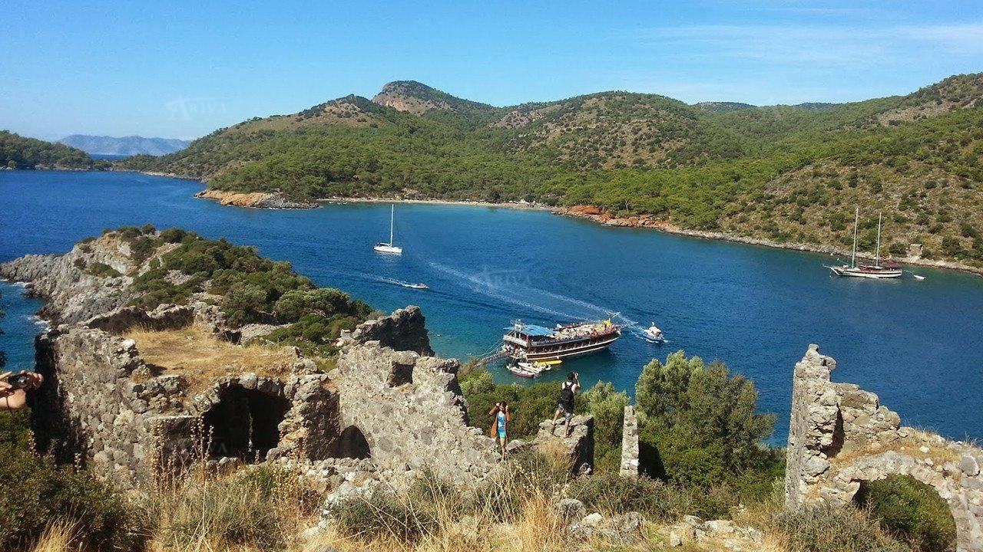
Tersane Island
Tersane Island or Shipyard Island, is the biggest in the Gulf of Fethiye. There is a deep, 100 m long channel which provides entry and the ‘’Shipyard’’ name comes as a result of that because it was home to the Ottoman Navy. There are plenty of coves and sheltered bays to the east side, which is known by some as summer harbour. The west side is subject to strong winds so it is largely ignored. There are some ancient ruins of a settlement called Telandria visible from the sea, and worth exploring on land. It was used by the Byzantines centuries ago.
Tersane Koyu is a winter port, providing all-round shelter. The settings are attractive. There is a pretty restaurant and a quay where berthing is available up to 15 boats. There are laid moorings tailed on quay. The ruins ashore are from the anchient boatyard settelements. A number of goats live on the island, their voice is higher pitched at night.
This anchorage gets crowded by excursion boats by noon time, but it is calm and quite at night. It is better to arrive in late and leave before noon the next day.

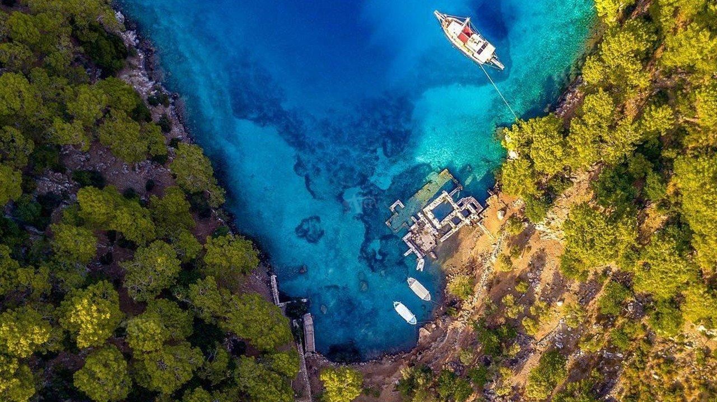
Cleopatra`s Bath
Manastir Bay is a volcanic area but everything is now dormant. There are many bays in the Gulf, formed many years ago and it is hard to imagine that the area was never anything than as peaceful as it is today. It is a hilly region covered in pine forest and there is an interesting crater lake as well. An ancient wall runs parallel to the north east coast. The Lycian remains are impressive and there are several opportunities for taking a trail to generally explore. Lydia Network Port is along one of those trails and the bay is a place where blue cruises and all passing yachts are likely to stop for a period; it is too tempting not to do so. Several restaurants with wooden pergolas hug the shore and find custom from the passing yachts. It is not a place for restocking but if you have plenty of supplies on board, you may decide to stay overnight, such is the tranquil beauty of the place.
Once a thermal spring supplied by the waters of a crater lake located behind mountains north of the bay, the area is still certainly well worth a dip. Equally, Cleopatra's Bay makes for a swoon-worthy snorkeling spot thanks to its mirror-clear waters.

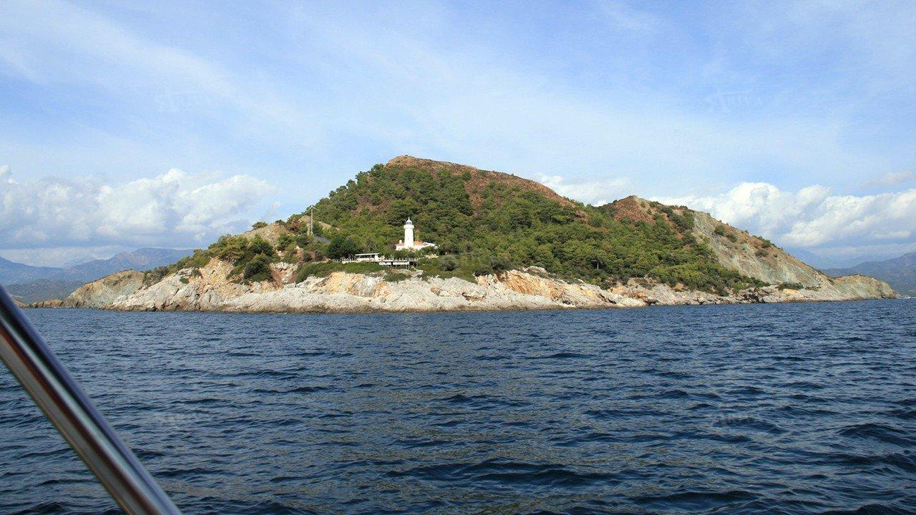
Kizil Ada
At sunset on Kizil, the sun hits the stones turning them crimson red in colour, the colour that is much the same as the island’s soil. The island gets its name from this phenomenon because it is the Turkish word for ‘’red.’’. There is little or no infrastructure on this island but at the southern tip there is a lighthouse to guide maritime traffic. The Deliktas Islands are to the north west, a great place for diving and fishing. The waves off the east coast wash on to the wide sandy beach where swimming is ideal.

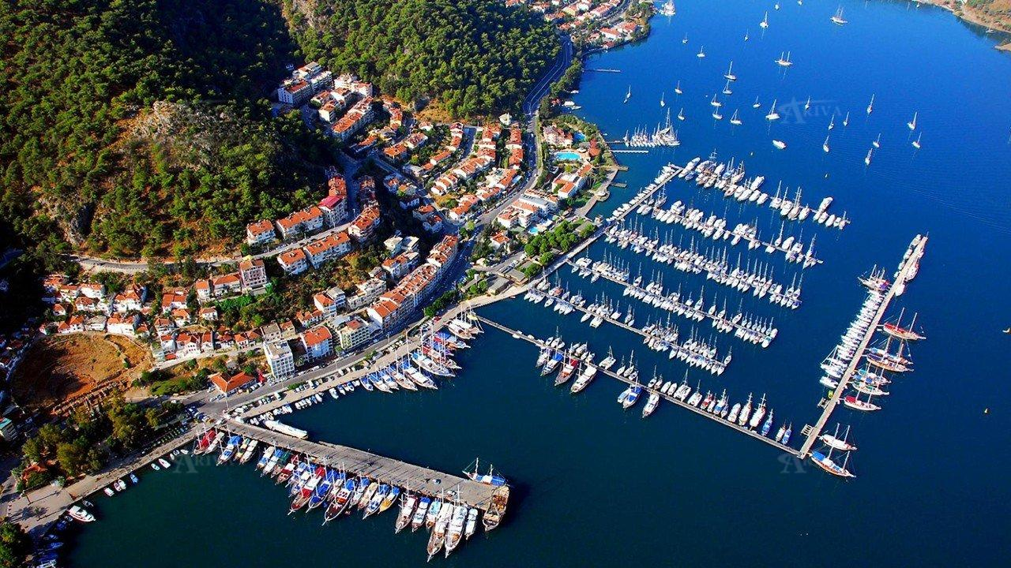
Fethiye
The ever-growing city of Fethiye lies only about half an hour by road from Dalaman Airport in South West Turkey. It is a naturally beautiful spot, a city beside the sea with many offshore islands adding to the quality of the environment. The region can boast lovely beaches and coves, many historical highlights with Fethiye’s bars and restaurants ensuring a great nightlife. Fethiye itself has ruins within its boundaries, temples and some interesting sarcophagi. A blue cruise out of Fethiye has much to recommend it, whether sailing east or west, and with 3 modern marinas ensuring the best of facilities for yacht charters.
26

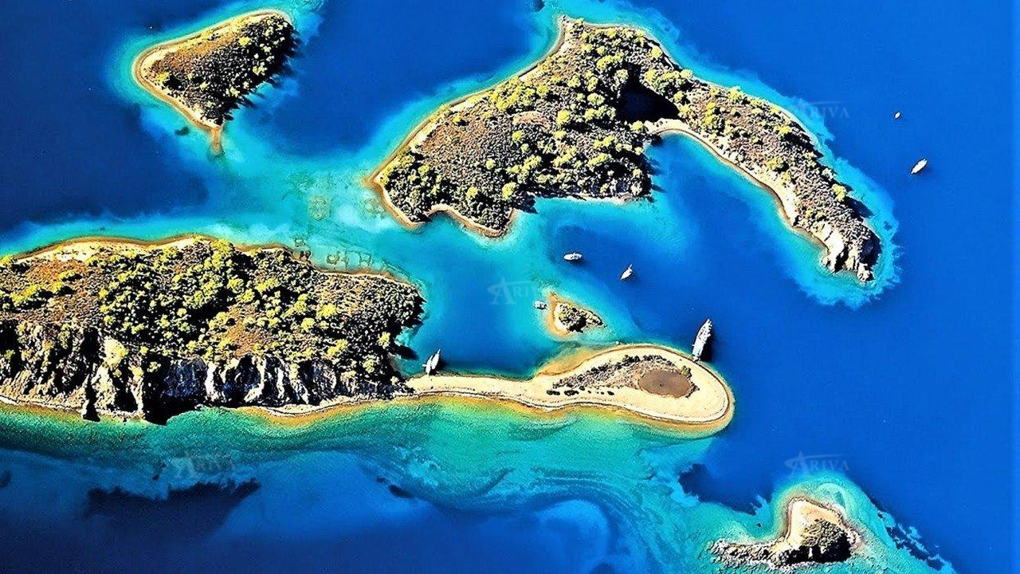
Yassica Islands
The Yassica Islands in the Gulf of Fethiye are visited on a daily basis by trippers as well as yachts that move up and down this coastline. They are uninhabited with no buildings on any of them but they provide great opportunities to anchor and swim. Many have small beaches as well. The vegetation is pine and olive and the shallow waters are ideal for a number of water sports. Certainly, they are very safe for children and hence popular with families. Some of the islands are very close together and it is easy to swim between some of them. If you want to explore it is advisable to have strong footwear with you because the ground is fairly stony. The nearest port to the Islands is Gocek which is the starting point for day trips into the Yassicas. You will get some great photos while you are among these islands and if you stay as the sun goes down, the sunset shot may be the best of the lot.
The eastern shores of Büyük Yassıca are lee from prevailing wind and it has steep slopes, but the western shoreline is wooded and has several adequate anchorages. There are floating moorings.
The strait between Büyük Yassıca and Kızıl Ada is shallow. One-metre reefs allow passage ony close to Yassıca (in 2 to 3m), but local knowledge is required to use it. It is much better to take the passage from the north. An islet, close to Kızıl Ada, there is a creek on the south, provides adequate shelter from prevailing winds with a line to bollard.
These anchorages are always loaded by excursion boats. It is always better to arrive in late afternoon and leave befor noon in the next day.
Diving courses and tours are organized in the vicinity.

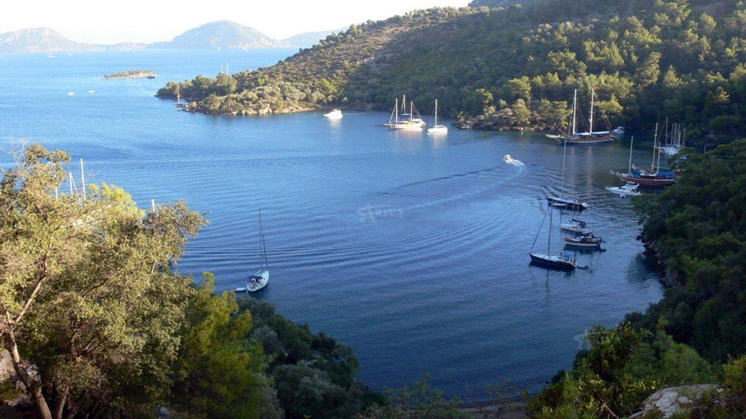
Bedri Rahmi (Tasyaka) Bay
Bedri Rahmi Bay has a Lycian name of Tasyaka or Dark Bay, a reflection of both its natural beauty and historical significance. Bedri Rahmi Eyuboglu was a famous Turkish literary man who also loved art and painting. Back in 1973 when he was cruising with friends, he drew a fish on a huge rock at the entrance to the bay. It is now known as ''Fish Rock'' which has become known as the name of the whole region. The Bay is well sheltered from any winds and as a result yachts often anchor there. The colour on the slopes is created by the pine trees, olive groves and especially the oleanders. Add to that the blue waters and the beach and the image is amazing.
There are number anchorages in this large bay. Depths are 10-15m. Boats drop anchor and take a line ashore. A bight next to jetty and NW corner are adeqaute anchorages. The water is very clear and the surroundings are wonderful. A low finger on the NW corner with Lycian ruins extends and features pretty beach where you can anchor or go stern-to the T-pier of the restaurant among pine and oleander trees. This pier has berthing capacity up to 25 boats.

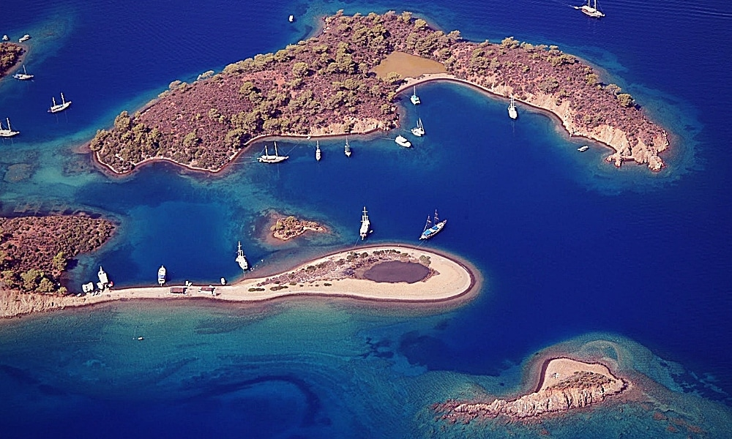
Boynuzbükü Bay
Opposite Yassica Island, between Bedri Rahmi Bay and Gocek, you find Boynuzbükü Bay. The bay is large and sheltered, with some good anchorages and decent depth in places (10m – 20m). Boynuzbükü Bay is an excellent spot to stop over or enjoy a few hours relaxing. There’s a local restaurant with a T-pier (depth 3m), and electric and water supplies for up to 20 yachts.

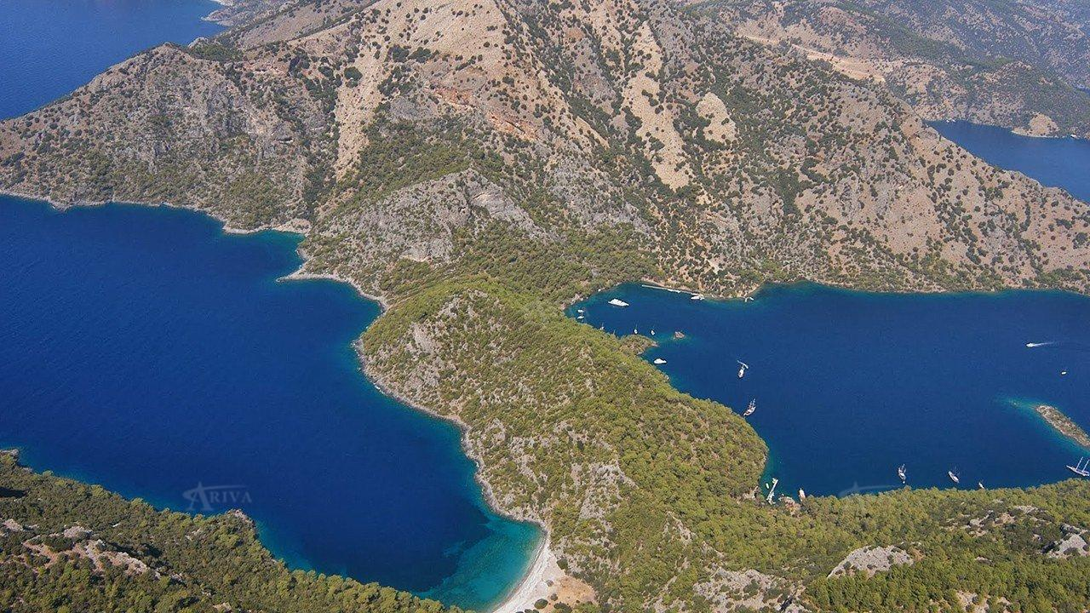
Sarsala Bay
Sarsala Bay is a popular bay with yachtsmen because it is a natural bay good for swimming or for staying overnight. The attractive bay has a long stony beach, a valley running inland which is covered with trees and is overlooked by Forestry Mountain. A restaurant and pontoon are found in Sarsala Bay where yachts regularly moor.
Boats anchor in 10-12 m off the beach side and swing at anchor. This anchorage is loaded by gullets.
A cove on the south beyond finger point is called Küçük Sarsala Koyu. Boats can anchor on either side of it. At the head of the cove there is a cozy restaurant with a T pier that has laid moorings tailed to it.
A large bay lies towards Bozburun which is called as Bozkoy is perfect for those who prefer serenity when Sarsala gets crowded.

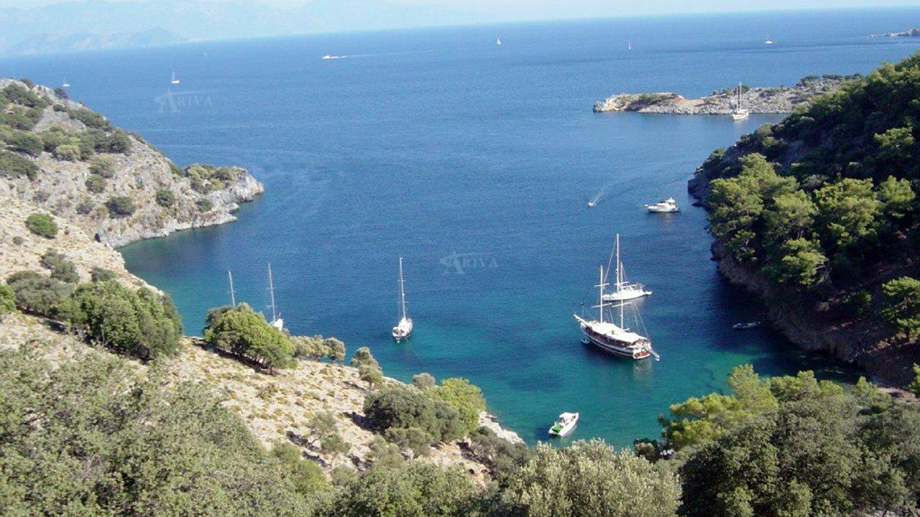2
Aga Limani
The twin bays of Aga Limani are a tempting place to drop anchor. They are close to the tip of Kurtoglu Bay within the Gulf of Fethiye and as a Network Port, you are able simply to relax, swim, try your luck at fishing or take even a long walk along the beach. The sea is extremely clean it and water is cooler than elsewhere as a result of the underwater source near the beach. If you follow the path to the bay for around an hour you will arrive at the ancient Lycian city of Lyda.
The bay is open to east. The cove on the west is Buyuk Koy, the one on the northwest is Kucuk Koy.
Kucuk Koy ends in a shingle beach. Boats can anchor in 8-10 m off the beach and take a line ashore. Prevailing winds cause swell.
Buyuk Liman, extends to the east, it narrows and ends in a shingle beach. The water is deep and gently shelves ashore. Boats drop anchor off the beach and get a line ashore to the beach side. Strong westerlies send in swell. Ease your chain as much as possible and pay attention to the rocky bottom in some parts.
The coves in Aga Limani are favourite stopover ports for boats cruising north and westward. When heading that direction, raise your anchor early before the breeze gets up to avoid cross-swell and choppy seas around Point Kurdoglu and Disibilmez.

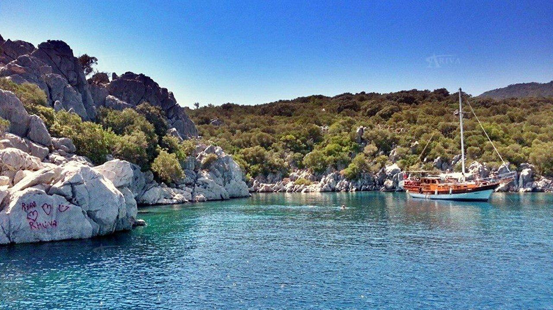
Kadirga Horbor
Kadirga Harbour is a pretty bay not far to the west from Marmaris. It is sheltered and has been awarded the blue flag because of its marvelous waters.
The entrance of the bay has no obstruction. There are sufficient depths. There is a rock by the tip on north. Kadırga Bay provides shelter from breeze and southerly blowing winds. It is open to northerly and easterly blowing winds. Prevailing wind sends light swell in. The depths gradually shelve ashore on the western part. The shore hosts nice shingle beaches.
Boats can be pushed off or anchored with a line ashore in SW, W and N shores of the bay, in 10-15m. There is a cove on NE part, the bottom is white debris. It is hard to heave the anchor to slip out from the bottom.
Steep rocks on SE are impressive platforms for cliff jumping.

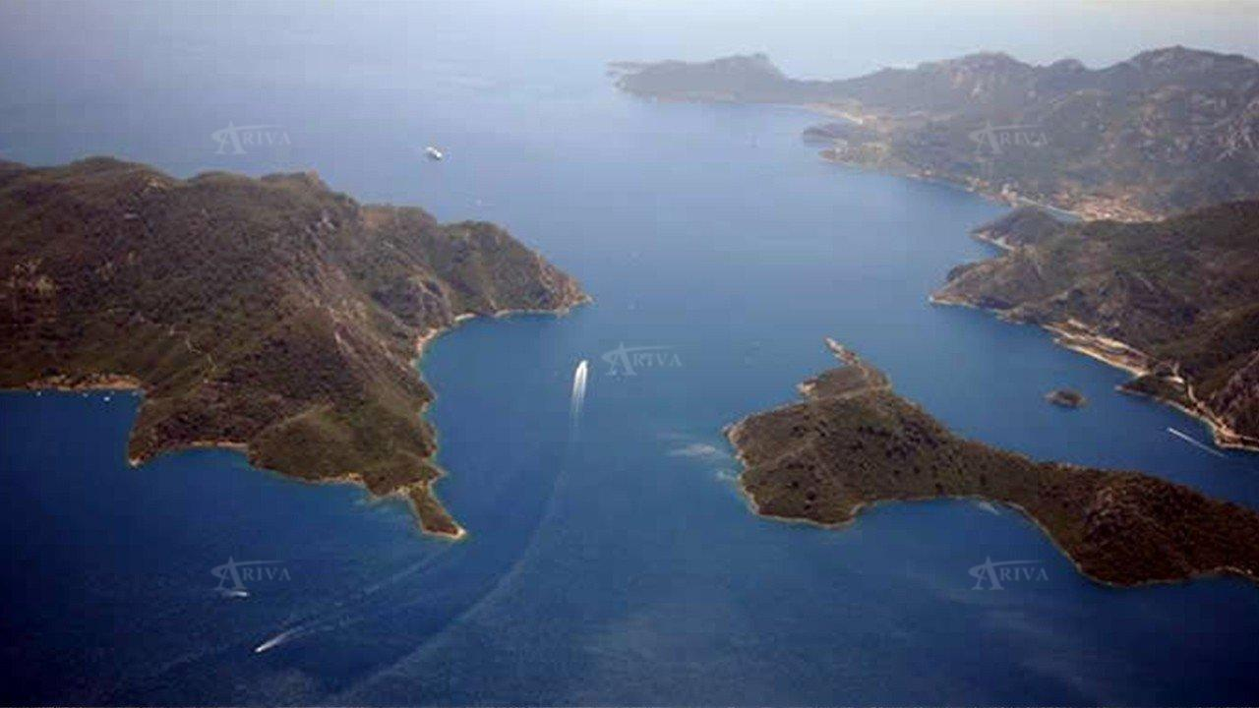
Star Island (Nimara)
Yildiz island is a wonderful peninsula in Marmaris. There are several nice cafes and restaurants across the island. It is ideal for those interested in swimming and snorkelling. Even if you spend a whole day on the island you are unlikely to get bored especially if you enjoy walking in a lovely natural environment. The area will remind you of a small sea channel. History says that a captain sailing in this area on a stormy night, hit the rocky landscape because he thought that this was a sea channel. Since then, it has also been known as ‘’wrong channel.’’

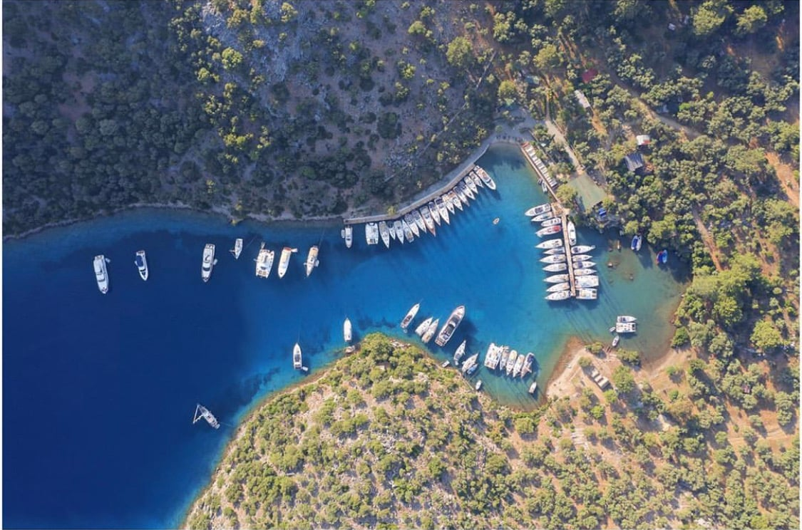
Gobun Bay
Gobun Bay cannot easily be identified from a distance. You will spot the bay only as pass the opening, which is between sheer cliffs. Larger boats cannot enter this cove as there is little space for maneuvering. There is 5 to 7m depth and the bottom is sand. The western side is shallow. There are underwater demolished walls from the ancient settlements. There is a low quay on starboard where there is room for a few yatchs. Boats can anchor in the middle and take a line to this quay. There are floating moorings of the restaurant. A quay of the restaurant has berthing capacity up to 40 boats. The area near by the head of the quay is rocky. It is best to go bows-to it to secure your rudder though long passarellas are provided by restaurant. The restaurant is one of the oldest restaurants in Gocek. They provide good food and service. They produce electricity from the solar panels. There is a barber next to the restaurant.
The settings are very attractive. Do not forget to climb up before sunset for a fabulous view of Gocek bay. Rough but nice path leads you to the ruins from the Roman period.

